ENGLISH
for
B΄ CLASS
LEVEL B1



Cosmas Markis (EFL Teacher)
3rd Junior High School of Preveza

CONTENTS
UNIT 1: ACCIDENTS & INJURIES ……….p.1-8
UNIT 2: DISASTERS………….. p. 9-15
UNIT 3: IN SICKNESS & IN HEALTH…… p.16-21
UNIT 4: THE WORLD OF SPORTS………… p.22-27
Unit 5: CHILDREN IN THE PAST…………………. p.27-34

UNIT 1: ACCIDENTS & INJURIES
Let’s Learn:
- Match the expressions with the pictures.
- I’ve broken my arm. 4. I’ve burnt my hand 7. I got an electric shock
- I’ve sprained my wrist. 5. I have a nosebleed 8. I got stung by a jellyfish.
- I’ve cut my thumb. 6. I hit my head 9. I twisted my ankle
a 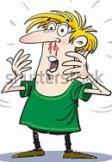 b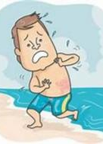 c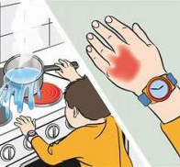d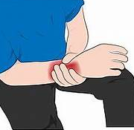 e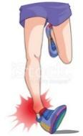f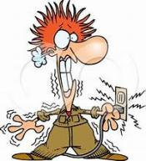g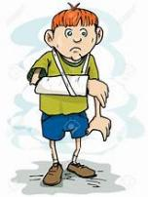h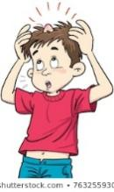i

- Match the phrases with the pictures.
- He’s unconscious 3. He’s bruised 5. He’s got a black eye
- It’s bleeding 4. He’s got a bump 6. He’s got a bad scar on the cheek.
a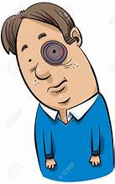 b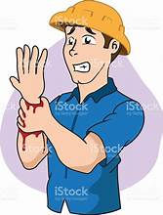 c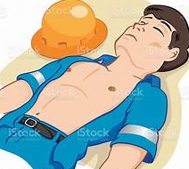d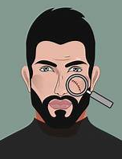 e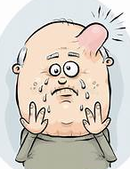f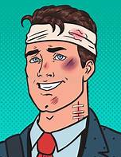

- OUT OF HOSPITAL: Match the descriptions with the pictures.
1. His leg’s in plaster. 5. His ancle’s bandaged up.
2. His arm’s in a sling. 6.He has stiches.
3. He’s walking on crutches. 7. He’s in a wheelchair.
4. He needs a walking stick. 8. He can’t walk without a zimmer.
a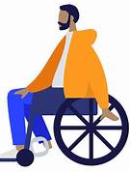 b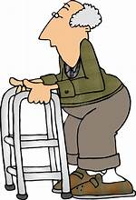 c 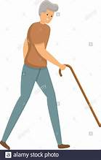 d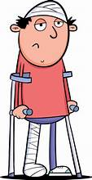e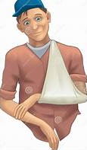f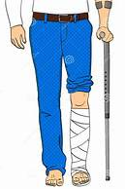g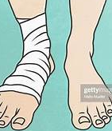 h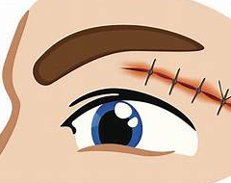

- Read the following paragraph and then write a similar one to describe an accident briefly.
Yesterday afternoon, I went to play basketball with my friends. I was very excited at the game. At a point, I made a high jump to score but I tripped over my feet and fell flat on the ground. I felt a terrible pain on my ankle. At first, I felt scared because I thought I broke my leg. I stood up but I could walk with difficulty. My dad took me to hospital. Luckily, it was not a broken leg but a twisted ankle. The doctor covered it with bandage and gave me some painkillers. Now, I have to rest in bed for two or three days.
1
Let’s Practise:
NARRATIVE TENSES (Past Simple / Past Continuous)
- What were you doing at the following times? Complete using the Past Continuous.
- (at 8 o’clock yesterday evening) ………………………………………………………………………………………………………………………………..………………………
- (at 11:00 last night) …………………………………………………………………………………………………………………………..…………………………..
- (at 5:00 this morning) ……………………………………………………………………………………………………………………….……………..……….……..
- (this time last week) …………………………………………………………………………………………………………………………….………………………..
- (half an hour ago) ………………………………………………………………………………………………………………………….……………………………

- Use your own ideas to complete the sentences. Use the Past Continuous.
- Tom burnt his hand while he …………………………………………………………………………………………………………..
- The doorbell rang while I …………………………………………………………………………………………………………………
- We saw an accident …………………………………………………………………………………………………………………………
- Mary fell asleep while she …………………………………………………………………………………………………………………
- The television was on but nobody ……………………………………………………………………………………………………

- Put the verbs into the correct tense (Past Simple or Continuous)
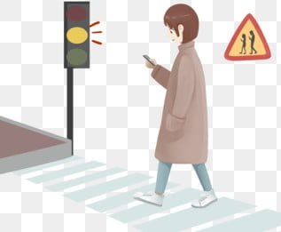
I ……………………………………….. (see) Jill in town yesterday but she …………………………… (not / see) me. She …………………………………………….. (look) at her mobile.
I …………………………………………. (call) her but she …………………………………………….
(not / hear) me because of the traffic noise.

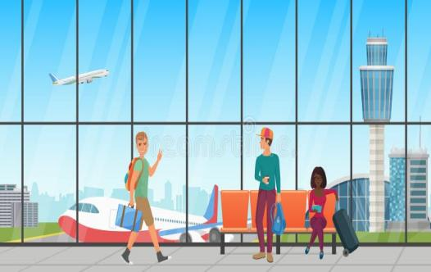
I ……………………………………………… (meet) Tom and Anne at the airport a few weeks ago. They …………………………………………… (go) to Berlin and I ……………………………………. (go) to Madrid. We …………………………………………….. (have) a chat while we ……………………………………… (wait) for our flights.

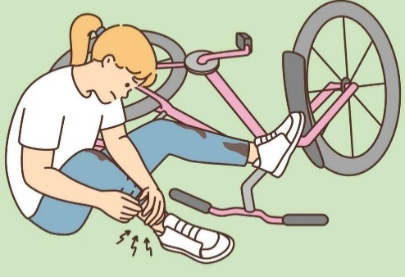
Sally ……………………………………..... (cycle) home yesterday. She ………………….
(be) in a hurry and ……………………………………………….. (not / notice) a deep hole in front of her. Before she ………………………………………… (know) it she ……………………………………… (fall off) her bike. Luckily, she ………………………………………………….. (not / be) seriously injured. She only ……………………………………………. (hurt) her ankle.
2

- How did it happen?
1. How did Bruce hurt himself? (play football)
………………. He hurt himself while he was playing football. ………………………………………………….
2. How did Martin burn himself? (iron his clothes)
……………………………………………………………………..………………………………………………………………………
3. How did Helen cut her thumb? (slice onions)
…………………………………………………………………………………………..…………………………………………………
4. How did Jennifer twist her ankle? (skate)
…………………………………………………………………………..…………………………………………………………………
5. How did Marvin break his arm? (ride his bike)
………………………………………………………………………………………………………………………………………………
6. How did you lose your wallet? (ride my scooter)
………………………………………………………………………………………………………………………………………………
7. How did Jeff get an electric shock? (fix the light)
…………………………………………………………………………………………….…………………………………………………
8. How did Bob get a black eye? (fight with his brother)
…………………………………………………………………………………….…………………………………………………………
9. How did your children burn themselves? (make breakfast)
………………………………………………………………………………………………………………………………………………
10. How did Martha fall? (dance)
………………………………………………………………………………………………………………………………………………

- What’s the matter? Make dialogues as in the example:
Who? | What was he / she doing? | What happened?
Tina | ice-skate | fall on the ice | break foot
Jack | play football | kick the goalpost | break leg
Bob | cycle | fall off the bike | injure hand
Ann | skate | fall over | break arm
Alice | dance | trip over the carpet | sprain ankle

Example: You : Hi, Tina! What’s the matter with your foot?
Tina : I broke it.
You : How did it happen?
Tina : I fell on the ice while I was ice-skating
Write sentences based on the dialogues.
eg. Tina broke her leg because she fell on the ice while she was ice-skating
2.Jack …………………………………………………………………………………………………………………………………………………….
3. Bob ……………………………………………………………………………………………………………………………………………………
4. Ann ……………………………………………………………………………………………………………………………………………………
5. Alice …………………………………………………………………………………………………………………………………………………..
3
Let’s Speak & Write: A FIRE IN MY NEIGHBOURHOOD
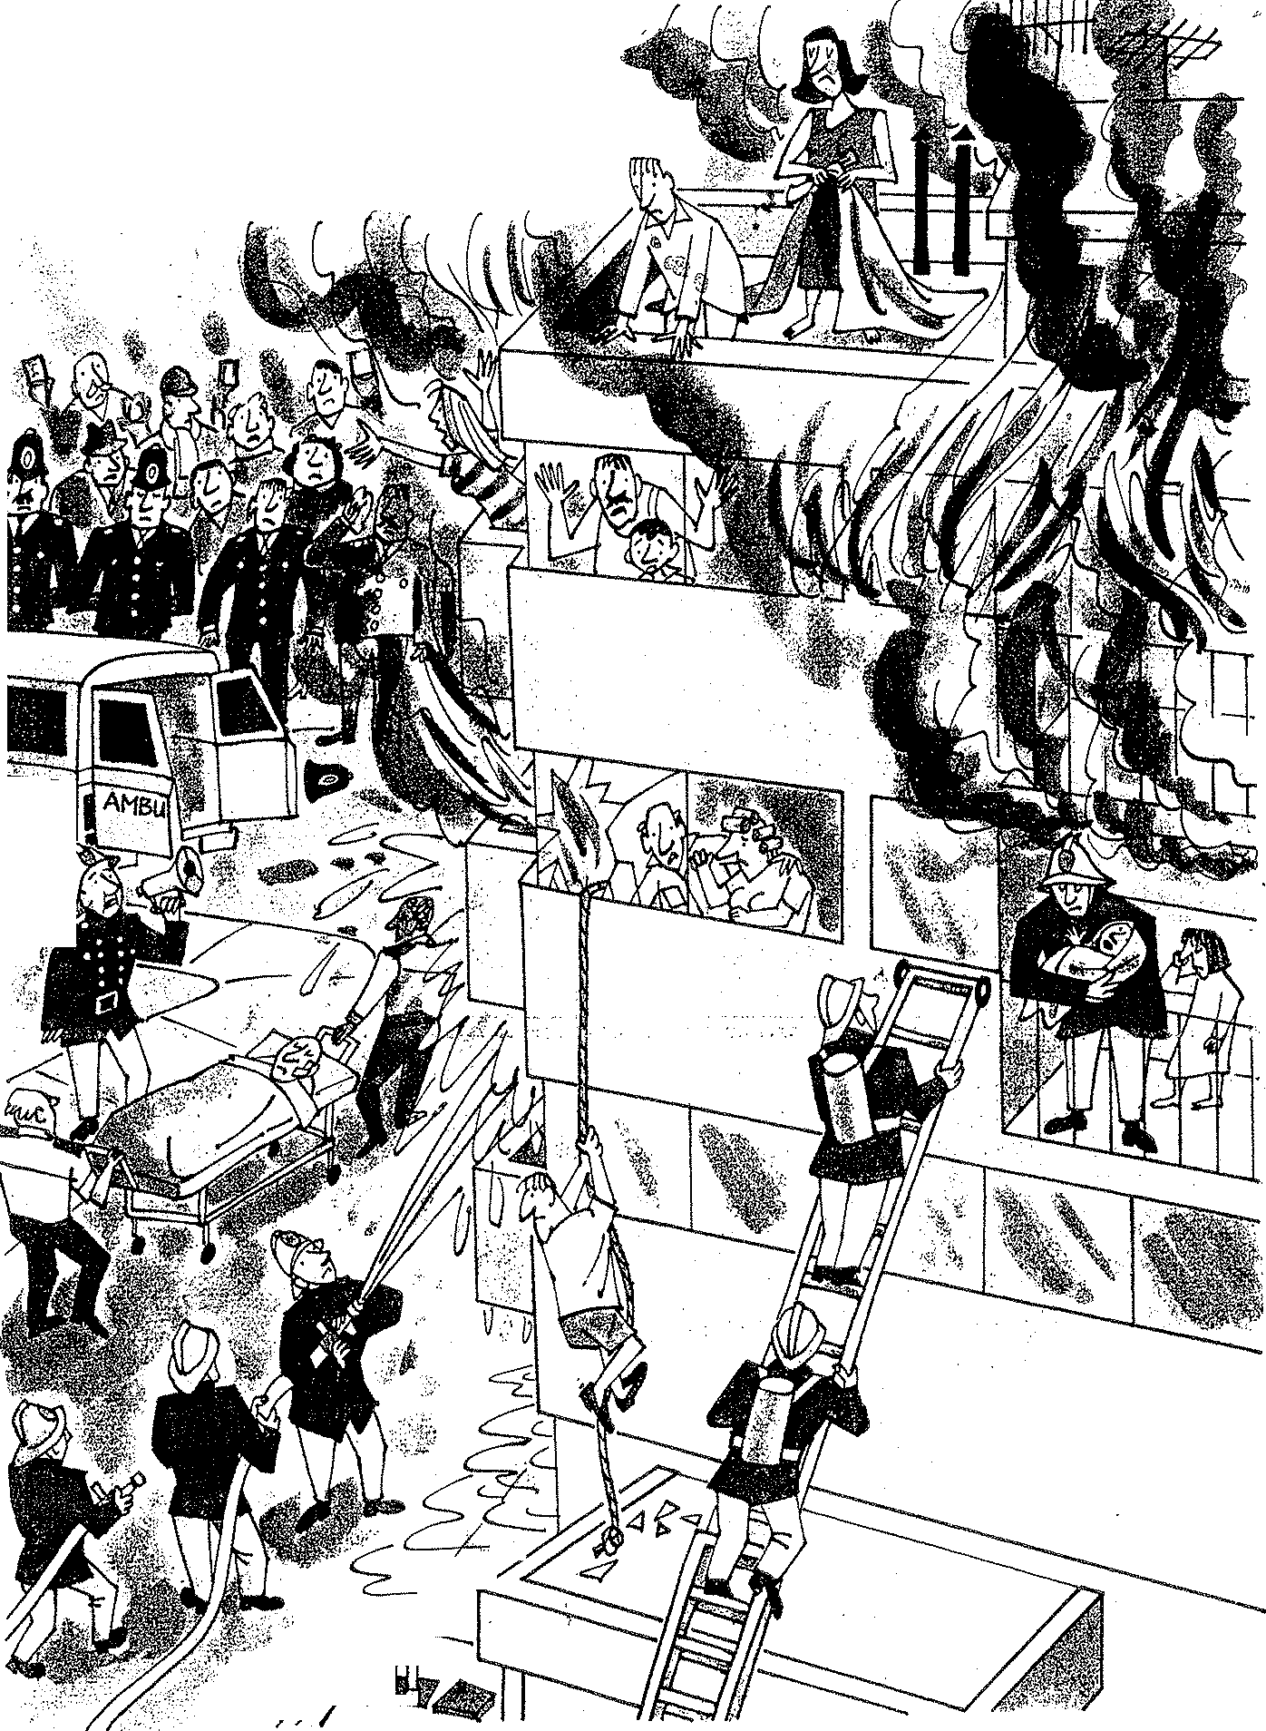

4
A fire in my neighbourhood
A. Find the people in the picture
1. people in the crowd 2. a row of policemen 3. two paramedics 4. the people in the building 5. firemen / firefighters 6. a baby 7. the baby’s older sister 8. a young man 9.the young man’s parents 10. Dad with his little son 11. mum 12. a couple

B. Imagine and say how the people in the picture seem
terrified upset relieved worried frightened distressed afraid nervous

C. Use the clues to say what the people were doing at the time of the fire.
- take pictures or videos / mobiles
- try / hold / crowd / away / the burning building
- carry / injured man / nearby ambulance / get / hospital
- shout / people / building / keep calm
- try / put out / fire / throwing water / a hose
- climb up / ladder / second floor / help / people / building
- hold / baby his arms
- cry / feel / upset but relieved.
- climbing down / rope / save himself / flames
- watch / son / feel / distressed / wait for help
- be / trapped / flat
- look / window / hope / firefighters / help them out
- scream for help.
- tie / sheets / climb down / the burning building

D. Use the clues above and write a story with the title: “A Fire in my neighbourhood”.
Use also the questions below to help you write the introduction and the conclusion.

INTRODUCTION
When? - yesterday afternoon
Where? -at home
What were you doing? - watch TV / do homework / play video games / chat online
What happened? - heard police sirens wailing outside
What did you do? -run out to the balcony / see what / going on.
What did you see? -when / get out / see black smoke everywhere / ambulance / rush / the end of the street / lots of people / run and shout.
What did you realize? - a building / on fire
What did you do next? - get out / house / go there / too / fire break out / block of flats / air /choking.
How was everybody feeling? - upset / terrified

CONCLUSION
What happened in the end?
Three hours later / firefighters manage / put out / fire / luckily / no one lose / lives / only / injured / taken / hospital.
How do you feel about the incident?
sorry / people / left homeless / at least / no casualties / everyone / safe and sound.
5
Let’s Read & Write: An accident
A.Emily has invited her friend Gina to her party next Saturday but she cannot go because she had an accident. Read Gina’s answer and complete her mail with the correct word.
pain top plaster set operation accident stumbled broken crutches ambulance
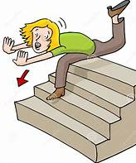
Dear Emily,
I was so glad to hear that you’re having a party next Saturday and normally I would look forward to coming – your parties are always top!
Unfortunately, I can’t make it because of a (1) ……………………………… leg. You know, I had an (2) ……………………………. at my own home four days ago. It was Thursday evening and I was listening to music in my room. Suddenly, I heard my mum calling me loudly – she must have called me several times but with my earphones on I couldn’t listen to her. I ran downstairs in a hurry when I (3) ………………………………. , slipped and that was all! I found myself at the end of the stairs with a terrible (4) …………………………….. in the leg. Mum called an (5) ……………………………….. , which took me to hospital. The doctor examined me, X-rayed my leg and found out it was broken. He managed to (6) …………………………… the bone and put my leg in (7) ……………………………………… . Luckily, I didn’t need an (8) ……………………………………………… I still can’t believe how this happened to me!
I’m now walking on (9) ……………………………… and still in hospital so I ‘m unable to come even if I want it so much. What a pity! Anyway, time flies and I’ll soon be on (9) …………………………………. of the world again. I wish I could come to your party. Maybe, next time. Love
Gina
- Use the clues to describe what happened to Emily.
listen to music / mum calling / earphones on / couldn’t listen / run downstairs in a hurry / stumble / slipped / find herself / terrible pain / leg / Mum call an ambulance /take her to hospital.
- Use the clues to describe what happened at the hospital
doctor examine / X-ray / find out / broken / set the bone / plaster / walk on crutches / still in hospital.
- How does she feel about the accident?

B.Match the verbs on the left (1–8) with the correct phrase on the right (a–h) to form common accident collocations. Then, complete the sentences

1. fall off | a. on a wet floor
2. lose / regain | b. a bone / your arm
3. stumble | c. consciousness
4. slip | d. a concussion
5. suffer / have | e. a bike / a skateboard
6. break | f. your ankle
7. twist / sprain | g. over a rug / a step
8. bang | h. your head

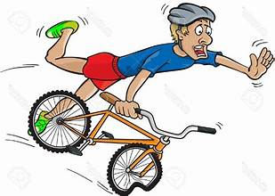
1- Mark was riding fast downhill when he lost control and fell ______ his ______. Luckily, he was wearing a helmet!
2- Be careful in the cafeteria! Someone spilled milk, and you don't want to __________ on the __________ floor.
3- During the basketball match, Sarah jumped for the ball, landed awkwardly, and __________ her ankle.
4- After the goalkeeper hit the post, he might suffer a __________, so the doctor needs to check him immediately.
5- Tom didn't see the messy cables on the floor. He __________ over them and dropped his phone.
6- When the boxer was hit, he ________ consciousness, but he woke up a minute later when the paramedics arrived.
7- Ouch! I wasn't looking where I was going and __________ my head on the low door frame.
8- If you fall down the stairs, you could easily __________ a bone in your arm or leg.
6
C. Bill has invited his friend Tanya to an international chess competition he’s taking part in but she cannot go because she had an accident. Look at the pictures that show how the accident happened and match them with the phrases a-g. Explain the words in bold.

- I heard a screeching noise as she slammed on the brakes.
- She lost control of the car because the road was wet and slippery.
- We were driving along a country lane when a red car pulled out of a side road.
- Mum swerved to the other side of the road to avoid hitting it.
- I banged my head on the windscreen and everything went black. I had passed out.
- She swerved over again to avoid collision and got into the way of an oncoming vehicle.
- The car skidded (on the road) and crashed onto a tree.
1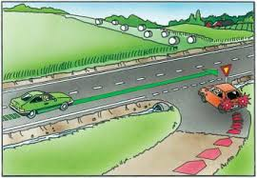 2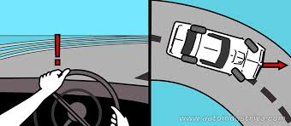 3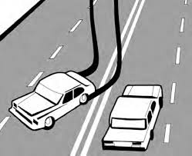4 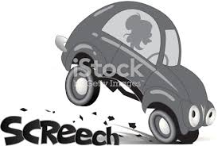
5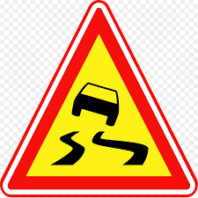 6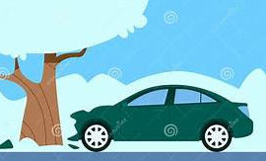7 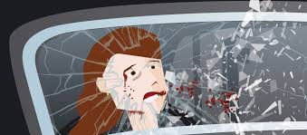 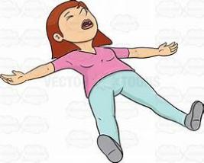
- Now, complete the letter with the accident description.
Hi Bill,
I’m so glad about the competition and I feel proud that you’re taking part. However, it’s impossible for me to come as last weekend I had a car accident and I’m still in bed!
It happened last weekend as mum and I were coming back from the Mall . ………………………………………………………………
….…………………………………………………………………………………………………………………………………………………………………………………………………………………………………………………………………………………………………………………………………………………………………………………………………………………………………………………………………………………………………………………………………………………………………………………………………………………………………………………………………………………………………………………………………………………………………………………………………………………………………………………………………………………………………………………………………………………………………………………………………………………………………………………………………………………………………………………………………………………………………………………………………………………………………………………………………………………………………………………
When I came round, I heard the wailing sirens of an ambulance, which took me to hospital. The doctors examined me and decided I had a minor concussion. They prescribed me some medicine and advised me to stay in bed. Mum’s got over it with some bruises on her arms but she’s very worried about me
As you can understand, I’m still in a state of shock. I’m really sorry I can’t attend your chess competition but I’m sure you’re going to be the winner. You’ve proved many times that you can beat even the most competent opponents and win. So, don’t worry at all. Just keep a cool head!
All the best
Tanya
7
D.Read the text and fill in with the missing sentences.
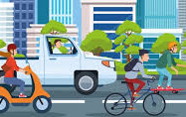
An Unexpected Afternoon
It was a sunny Tuesday afternoon, and Tom was riding his bicycle home from school. The air was warm, and the streets were relatively quiet.(1) ……………… He was wearing his shiny blue helmet and listening to the traffic noise as he pedaled down Main Street.
Suddenly, near the local bakery, a blue car parked on the side of the road stopped without warning. Before Tom could react, the driver opened the car door right in front of him. Tom tried to brake as fast as he could, but there was not enough time or space. (2) ……….. The impact threw Tom over the handlebars, and he fell heavily onto the asphalt road. His bike skidded to a stop a few meters away.
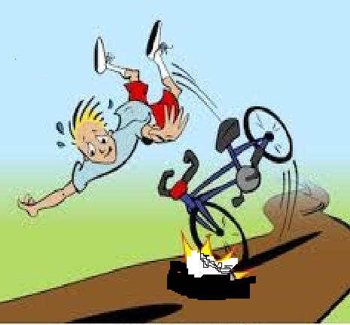
For a moment, everything went quiet.(3) ……. Fortunately, the driver immediately jumped out of the car to check on him.
"I am so sorry! I didn't see you coming!" the driver said nervously, helping Tom sit up slowly.
A few kind pedestrians also stopped to help. (4) ……….. Luckily, Tom was wearing his helmet, which protected his head from a serious injury. He only had a few minor scrapes on his knees and a bruised elbow.
However, his bicycle was not as lucky. The front wheel was completely bent, and the chain had fallen off. (5) …… Although Tom was shaken by the accident, he was extremely grateful that he was not badly hurt. He learned an important lesson that day: always watch out for parked cars!

A. Tom lay on the ground, feeling shocked and confused.
B. The driver apologized again and offered to pay for the repairs.
C. Tom loved cycling because it was great exercise and saved him money on bus tickets.
D. One person brought Tom a bottle of water, while another checked his bicycle.
E. His front wheel slammed into the car door with a loud bang.

Complete the sentences below using the correct word in bold.
- When the cat ran in front of the car, the driver had to ……………………………………… hard to avoid hitting it.
- Be careful on the wet road! Your bike might ……………………………………. if you turn too quickly.
- Keep both hands on the …………………………………………….while you are riding down the hill.
- The streets were quiet today compared to yesterday, so it was …………………………………… easy to find parking.
- A kind ……………………………………………… helped the lost tourist find the nearest train station.
- She felt very …………………………………………… when her neighbors helped her carry the heavy groceries upstairs.
- He fell off his skateboard on the pavement and got a minor ………………………………………. on his arm.
- During the storm, a big tree branch fell and ……………………………………………. the roof of the house.
- You have to …………………………………………… faster if you want to reach the top of the steep hill.
- The helmet absorbed most of the …………………………………………. when he bumped his head against the tree.

E.Your friend Mark has sent you a short mail inviting you to spend a weekend at his home by the sea. Sent him an e-mail between 100-150 words saying that you cannot go because you had an accident and describe it in detail.

Dear Steve,
How about coming to my home by the sea next weekend? We could enjoy the sea together, do water sports and even go scuba diving.
I think it would be wonderful. What do you say?
Mark

8
UNIT 2: DISASTERS
Let’s Learn
Write the correct word under the picture
Natural Disasters
earthquake tsunami blizzard avalanche storm volcanic eruption tornado flood
1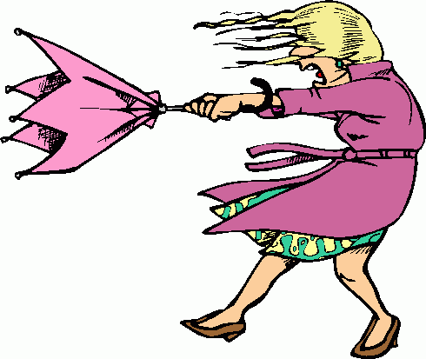 2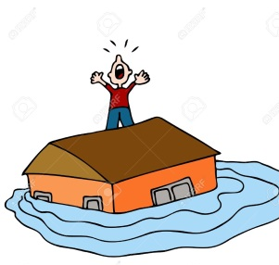 3 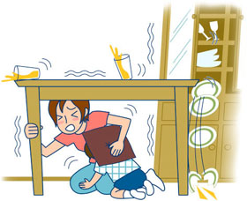 4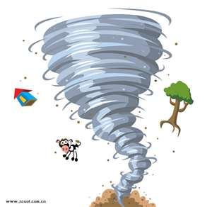

5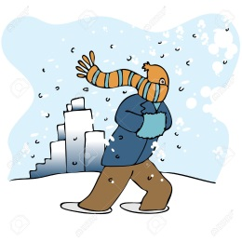 6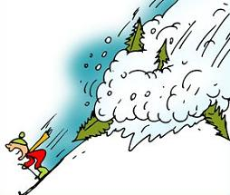 7 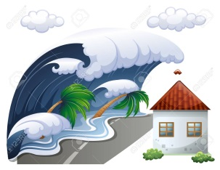 8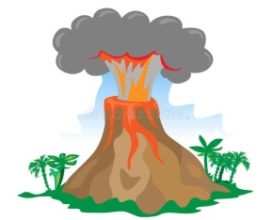

Manmade Disasters
war fire famine nuclear explosion
1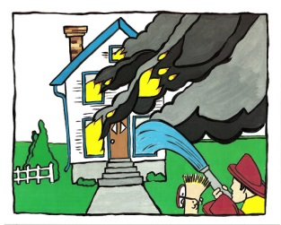 2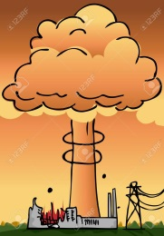 3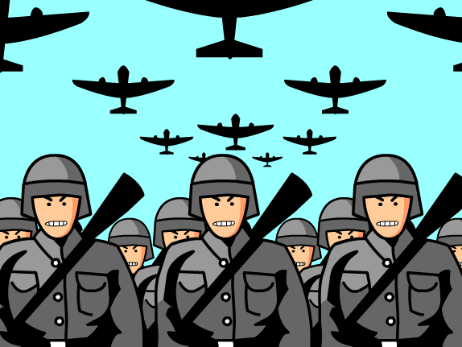 4 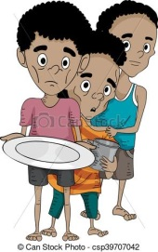

Which disaster are the sentences about?

- It had been snowing for two days! We could hardly get out of the house!
- The big wave swept away the whole village. There were many casualties.
- Hot lava and gases erupted out of the volcano.
- The soldiers marched in the town and bombed everything.
- Suddenly, the earth started to shake. Several buildings collapsed and buried people under the debris.
- After downpours of torrential rain, the drains blocked and the river burst its banks.
- Huge snow waves rolled down the slope. Two skiers are missing.
- The house was covered in flames. The fire brigade managed to put it out after four hours.
- There will be gale-force winds and rain showers. Citizens are advised to stay home.
- Most countries in the third world suffer from lack of food.
- The hurricane uprooted trees and destroyed houses on its way.
- The plantation exploded with a loud bang.
9
Let’s Practice: The Past Perfect
- Use the clues and complete with the Past Perfect.

- You went to Daniels’s house but she wasn’t there. (go out)
………………………………………………………………………………………………………………………………………………………
- You visited your home town after many years. But it wasn’t the same as before. (it / change / a lot)
……………………………………………………………………………………………………………………………………………………….
- I invited Sue to the party but she couldn’t come. (she / arrange / do something else)
………………………………………………………………………………………………………………………………………………………..
- You went to the cinema last night but you arrived late. (film / already / begin)
..............................................................................................................................................................
- I was pleased to see Dave again after such a long time. (not see / for years)
…………………………………………………………………………………………………………………………………………………………
- I offered Sue something to eat but she wasn’t hungry. (just / have / breakfast)
…………………………………………………………………………………………………………………………………………………………
- Last summer we went to Denmark. It was our first time there. (not be / before)
………………………………………………………………………………………………………………………………………………………….

- The following sentences tell a story in the order it happened. Use them to tell the story in a more interesting way. Begin with the underlined sentence.

1. Somebody broke into the office last night.
2. We arrived at work in the morning.
3. We called the police.
…………………………………………………………………………………………………………………................
…………………………………………………………………………………………………….……………….………….
……………………………………………………………………………………………………………….….…………….
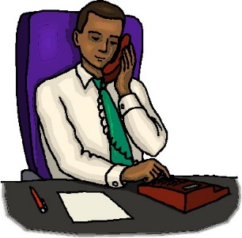
1. Fay went out.
2. Her boss tried to find her on the phone.
3. There was no answer.
…………………………………………………………………………………………………………..……………..…………....
………………………………………………………………………………………………………….……..……….…………….
……………………………………………………………………………………………………….……………………………….
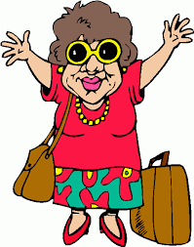
1. Milly came back from holiday last Monday.
2. I met her the same day.
3. She looked great.
………………………………………………………………………………………………….………………..……………….……..
……………………………………………………………………………………………….……………….……..…………………..
……………………………………………………………………………………………….……………..….………………………..


1. Laura texted Celia many times.
2. She never replied to her messages.
3. Yesterday, she had a phone call from her.
4. She was surprised.
…………………………………………………………………………………………………………………………………………….
………………………………………………………………………………………………………………………………………………………………………………………………………………………………………………………………………………………………………………………………………………………………………………………………………………………..…
10
- Complete with SIMPLE PAST or PAST PERFECT:
1. They ……………………………. (go) home after they ………………………….. (finish) their work.
2. She ………………………………….. (just / go) out when I called her.
3. My brother ………………………………. (eat) all the pie before we got back.
4. He wondered why I …………………………………………. (not / visit) him before.
5. Lyn said that she ……………………………………………. (already / see) the Pyramids.
6. The fire ……………………………….. (spread) to the next building before the firemen ……………………………………….. (arrive).
7. They drank some coffee, after they ………………………………………. (finish) dinner.
8. Bryan told me he ……………………………………………….. (catch) a young lion.
9. His mother …………………………………………. (be worry) a lot about him before she ……………………………………… (hear) that he was safe
10. He ……………………………………………….. (already / learn) English before he …………………………………………. (leave) for England.
11. Mary ………………………………………….. (go) swimming after she …………………………… (come) home.
12. I ……………………………………… (go) to the theatre with my friends yesterday. I ……………………………… (not / be) to the theatre for a year.
13. After they ……………………………… (finish) their breakfast, they …………………… (leave) for school.
14. Linda ……………………………………. (play) tennis after she ………………………… (do) her homework.
15. My father ……………………………. (water) the flowers after he ………………………. (clean) the car.

- Combine the following sentences by using AFTER / BEFORE:
1. I heard a rumbling noise. The earthquake began.
…………………………………………………………………………………………………………………………………………………….….
2. Frank heard a loud thunder. Then he saw a bolt of lighting..
…………………………………………………………………………………………………………………………………………………….….
3. I washed the dishes. I watched TV.
……………………………………………………………………………………………………………………………………………..…………
4. Sue washed her hands. She had lunch.
…………………………………………………………………………………………………………………………………………..……………
5.The earthquake stopped. We got out of the house.
…………………………………………………………………………………………………………………………………………………………
6. There were gale force winds. The storm began.
…………………………………………………………………………………………………………………………………………………………
7. The thieves ran away. They broke the window.
………………………………………………………………………………………………………………………………………………………..
8. I fastened my seat belt. The plane took off.
…………………………………………………………………………………………………………………………………………….…………..
E. Complete the following sentences:
1. After I had watched that horror film, I ………………………………………………………………………..………………
2. She finished her homework after ………………………………………………………………………….…………………….
3. When I came home, my sister ………………. already ………………………………………………………………………
4. Before he went out, ……………………………………………………………………………………..………………………………
5. They had telephoned me before …………………………………………………………………………………………………..
11

Let’s Read: A storm at sea
A.Put the words and phrases under the right picture. Then use them to complete the story.
lightning scared to death sea became rough set out on a sailing holiday shouting
the storm flames on the deck dark clouds coast guard rescued
a gust of wind mast rocking from side to side thunder
a 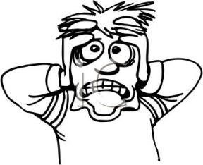 b 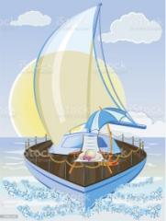 c 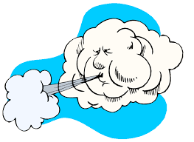 de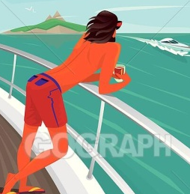
……………………………….. ………………….. ………………………………….. ………………………….. …………………………….
f  g  h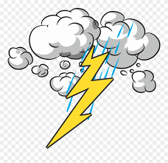 i 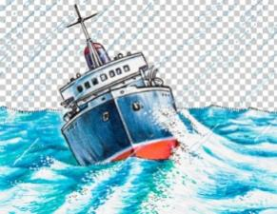 j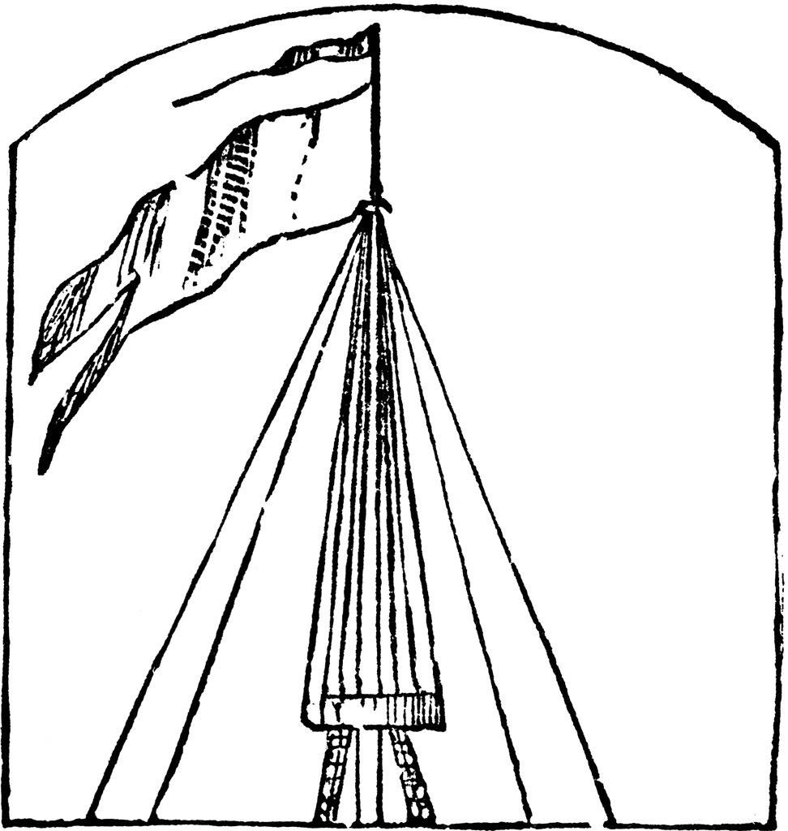
………………………………….. …………………………………. ……………………….. ……………………………….. ………………..
k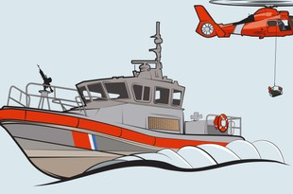 l 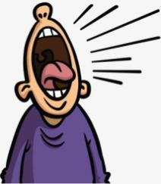 m n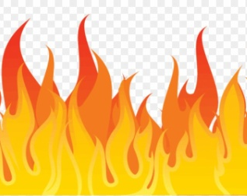 o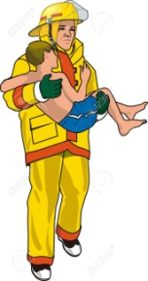
…………………………………….. ……………………….. ………………………………… ………………………………. …………………
Last summer, Alex and his uncle were excited when they (1) _______________________ along the Greek coast. The morning was warm and sunny, but by late afternoon, the weather suddenly changed. Heavy, (2) _____________ gathered in the sky, hiding the sun.
Within minutes, (3) _______________________ hit the boat, making it pitch wildly. The water turned choppy, and the (4) _______________________, tossing the small yacht across the waves. Alex stood (5) ___________________, holding tightly to the railing as the boat kept (6) _______________________.
Suddenly, a bright flash of (7) _______________________ split the sky, followed immediately by a deafening roar of (8) _______________________. The situation got even worse when the lightning struck the tall (9) ______________ of the boat. Bright red (10) _______________________ quickly broke out near the top of the sail.
-"Get the fire extinguisher!" Alex’s uncle was (11) _______________________ over the sound of the howling wind. Alex was (12) _______________________, but he managed to run to the cabin to grab the safety gear while his uncle sent out an urgent MAYDAY call.
Fortunately, as (13) _______________________ raged around them, help was already on the way. A hero vessel from the local (14) _______________________ arrived through the high waves just in time. They put out the fire and (15) _______________________ Alex and his uncle, bringing them safely back to shore. It was a lucky escape and an adventure they would never forget!
B.Read the statements below and choose True (T), False (F), or Doesn't Say (DS). For the open questions, answer in complete sentences.
- Alex and his uncle went on a sailing trip during the winter. [ T / F / DS ]
- The weather was bad from the moment they left the port. [ T / F / DS ]
- Lightning struck the boat's mast and caused a fire. [ T / F / DS ]
- Alex's uncle called his family to tell them what happened. [ T / F / DS ]
- The coast guard saved Alex and his uncle. [ T / F / DS ] 12
- How did the boat react when the strong gust of wind hit? ………………………………………………………………………………
- What did Alex's uncle ask Alex to do when the fire started? ...............................................................................
- How did Alex feel during the storm, and what did he do despite his fear?...........................................................

C. Choose the Correct Form
- Alex helped / was helping on the boat when the sky suddenly grew / was growing dark.
- While the wind blew / was blowing loudly, Alex's uncle sent / was sending a MAYDAY signal.
- Bright flames broke out / were breaking out on the mast while Alex ran / was running to fetch the fire extinguisher.
- When the coast guard arrived / was arriving, the storm still raged / was still raging.
D. Put the verbs in brackets into the Past Simple or Past Perfect Simple.
1.Before Alex and his uncle set out, the weather forecast _____________________ (promise) a beautiful, warm day.
2. By the time the dark clouds appeared, they _______________________ (sail) several miles away from the port.
3.Alex was scared to death because he _______________________ (never / experience) such a severe storm before.
4.When the lightning struck, it immediately set fire to the mast that they _______________________ (repair) the week before.
5.Alex’s uncle realised he _______________________ (forget) where he placed the second fire extinguisher.
6.Fortunately, the coast guard arrived quickly because the uncle _______________________ (already / send) a MAYDAY signal.
7.By the time the rescue boat reached them, the fire _______________________ (destroy) most of the sail.
8.Alex and his uncle _______________________ (thank) the heroes who had saved their lives.

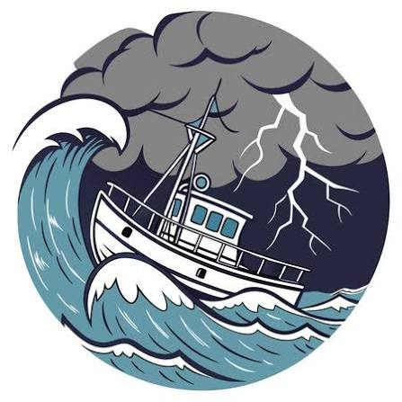

D. Put the Story in Order: Write the numbers 1 to 6 in the boxes to tell the story in the correct order.
Order | Sentence
 | A. Suddenly, lightning struck the boat's mast, causing a dangerous fire to break out.
 | B. Alex and his uncle set out on a peaceful sailing trip along the Greek coast on a sunny morning.
 | C. Fortunately, the coast guard arrived just in time to put out the fire and save them.
 | D. By late afternoon, dark clouds gathered and a violent storm made the sea very rough.
 | E. While his uncle shouted orders and sent a MAYDAY call, Alex ran to get the fire extinguisher.
 | F. The boat started rocking wildly, and Alex was scared to death as the thunder roared.
13
Let’s Read: The Flood

My name is Keith Jones and I live in Queensland, Australia. This is my story of how I survived a terrible flood, three years ago. Queensland is a rainy area and people are used to heavy rains but nothing could have prepared us for what we would experience. The weathermen on TV and the internet had been giving warnings about the powerful thunderstorm that was coming towards us, advising the residents to stay home and not move out at all. They proved to be right as it wasn’t an ordinary flood. In fact, it was so powerful that it took everyone by surprise.
At about 11:00 am, the sky turned black and it started raining. Soon, the rain became so heavy that it sounded like bombing. Me and my family, dad, mum and my little brother had been locked at home putting sand bags and towels outside the door to keep water from coming into the house. We were looking out of the windows but we could hardly see what was going on outside. Three hours later the torrential rain kept falling without giving any signs of stopping.
Feeling terrified, we saw the road in front of our house had turned into a little river, sweeping away cars and little trees. Dad was trying to catch up with the news on his mobile when there was a power cut.
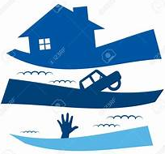
“Look! The water’s coming in through the door,” mum screamed in terror. “Hurry up, let’s go upstairs.”
We rushed on the first floor of the house only to see that the nearby river had burst its banks and the water was quickly turning our neighbourhood into a lake!
“Run, let’s get on the roof,” dad shouted and took my little brother in his arms. Mum grabbed some blankets and we climbed on top of the house.
From up there, we saw our whole area had been covered by water which was getting higher and higher. All the residents were on their house roofs praying and crying for help. There was no electricity, no phones, we were alone and desperate. It was worse than a nightmare.
The flood had almost reached the roof and the whole house was now underwater. We were hopeless.
Suddenly, we heard the sound of helicopters. We looked up and saw them coming to rescue us. A helicopter hovered right above us and the rescue team threw us a ladder to climb up. As soon as we all climbed on it, they gave us warm clothes and hot tea and got as to a safe place.
The rain stopped early in the evening but our neighbourhood was now flooded under the water. It was a terrible experience but, at least, we are relieved to be alive. 22 people lost their lives in the flood and 58 were injured and carried to hospitals.

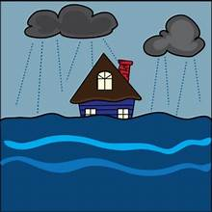
- What is characteristic of the area Keith Jones lives in?
- What had the weathermen been doing?
- How had Keith’s family been prepared for the flood?
- What did they see outside the window?
- What did they see from the first floor?
- What did they decide to do?
- How did they feel on the roof?
- How were they saved?
- What was the outcome of the flood?
- How does Keith feel?

- Explain the highlighted words and expressions and use some of them to complete the sentences.
- The river ………………………………………….. and flooded the whole village.
- After hours of ………………………………………….. the whole town was flooded.
- The rain started unexpectedly and ……………………………………………………………. .
- The ……………………………………………… managed to save all the people in the area.
- After losing their homes in the flood, the people felt ………………………………………… .
- Susan managed to ……………………………………. her handbag before she run out of the flooded building.
- The thunderstorm caused a ……………………………………. and there was no electricity for days.
- We saw the flood …………………………………. vehicles and rubbish bins.

- Look back at the questions. Use them to make a short summary of Keith’s story.
14
Let’s Watch: How do earthquakes happen?
https://www.youtube.com/watch?v=Rmkds_ox_6k
Watch the video and complete the sentences with the missing words.
world terrible back and forth shook moving caused split predict ground fall cover damage
1. When an earthquake happens, the whole ground beneath your feet is ............................................
2. Sometimes, things on shelves and ceilings .......................................
3. Strong earthquakes are ....................................... and destructive.
4. Some ancient Greeks believed that earthquakes were ............................................. by God Poseidon.
5. In the earthquake of San Francisco, in 1906, the ground ............................................. for 45 seconds non-stop!
6. Buildings fell apart and there was a huge amount of ..................................................
7. There were cases of fences that had been .................................... and moved. They were all connected in a line.
8. There are fault lines all over the .......................................
9. When two sections of land push away each other the ................................................... starts to shake violently.
10. It’s dangerous when buildings and houses start swaying ............................................
11. It’s important to duck and ........................................ during an earthquake to protect yourself from falling objects.
12. Scientist still cannot fully ............................................. an earthquake.

Let’s Tell a Story: An Earthquake
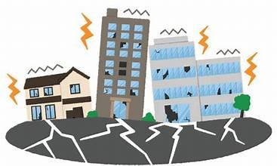
Who/When/Where?
..………………………………………………………………………………………………………………………………….
What were you doing?
….……………………………………………………………………………………………………………………………………………………………………………….What happened?
hear a low rumbling noise/ look at ceiling / light started swaying back and forth
before I knew it / another rumbling noise / room start shaking / fall flat on the floor
duck and roll under the table / wait for the earthquake to stop
vases fall off selves / smash into pieces / books fall off bookcase / pictures fall off wall
whole house jump up and down / terrible noise
How did you feel?
….……………………………………………………………………………………………………………………………………………………………………………….What did you do after it stopped?
….……………………………………………………………………………………………………………………………………………………………………………….Was anyone injured?
….………………………………………………………………………………………………………………………………………………………………………………..How did it end?
stay out all night / afraid of aftershocks /lucky to be safe and sound

Use the clues to tell and write a story with the title: An earthquake
15
UNIT 3: IN SICKNESS AND IN HEALTH
Let’s Learn: Feeling ill
- Match the phrases with the pictures.
have a cough have/be down with the flu my arm hurts feel dizzy have a stomachache have / catch a cold have a sore throat have a temperature have a headache
have a pain in my knee have a backache have a rash have a toothache
1 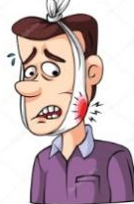 2 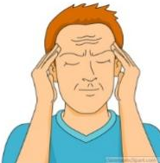 3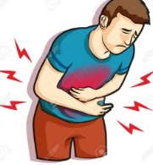 4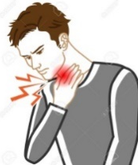 5 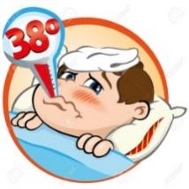 6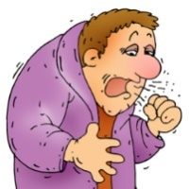 7 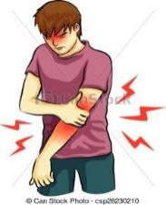
8. 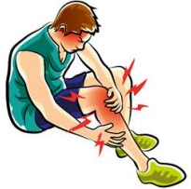 9 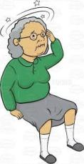 10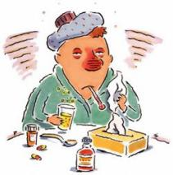 11. 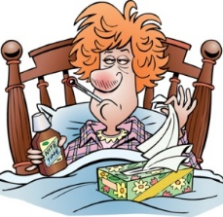 12. 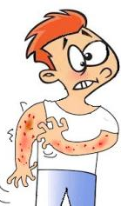 14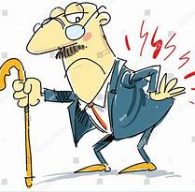

2. What should you do if you …? Match the symptoms in ex. 1 with the advice. Make sentences as in the example.
eat lots of fruit and vegetables stay in bed visit a dentist take some cough tablets
see a doctor stay indoors put on some cream relax and not move relax for a while
take medicine take an aspirin/a painkiller drink some tea put on a bandage

- What should you do if you have a headache?
- If you have a headache, you should take an aspirin / a painkiller

- Complete the sentences with the words:
cough symptom appointment virus rash medicine infection prescription

- Could I come late in tomorrow? My wife and I have an ……………………………………… at the doctor.
- That’s a nasty ……………………………… you’ve got. You’ve really got to stop smoking.
- The main ………………………………. of measles is little red spots all over your body.
- I sometimes get a …………………………… on my face after I’ve been shaved.
- I’m taking antibiotics for this ear ……………………………………….. .
- Covid 19 was a really deadly ……………………………………….. .
- Very often, rest is the best ……………………………………………
- Did you take that …………………………………. at the chemist’s?
16
In Hospital
- Match the following words and phrases with the pictures 1-13. Then use them to complete the text.
in a lot of pain as pale as a ghost in plaster blood sample a twisted ankle stethoscope
stitches a broken wrist ear infection prescription bandaged treated
a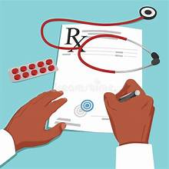 b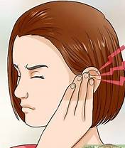 c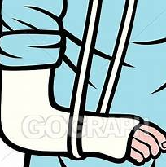 d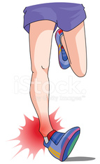 e f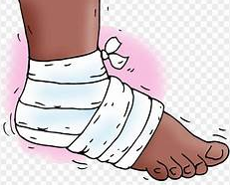 g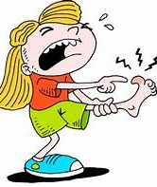 h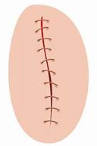 i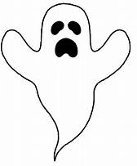 j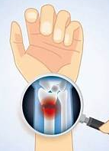 k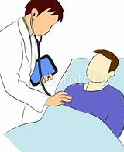 l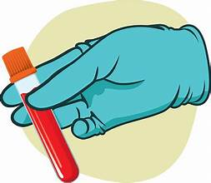
Last Saturday was complete chaos at the local clinic! First, my cousin Sam had to be (1) ________________ by the doctor after tripping over a root while playing football. His leg was swollen and he had (2) ___________________. The nurse wrapped it up tightly so it was fully (3) ______________________ before sending him home to rest.

While we were waiting, my friend Sarah arrived looking (4) ____________________________ because she was
5) _____________________. She had fallen off her skateboard, and the X-ray showed she had (6) ______________ . The doctor told her she would need to keep her arm (7) ______________________ for six weeks!
Next to us, a young girl was crying. The doctor listened carefully to her breathing using a (8) ___________________ . After that, a nurse gently took a (9) _____________________ from her arm. It turned out the girl didn't have a chest problem, but she was suffering from a painful (10) __________________________. The doctor gave her mother a (11) ______________________ to pick up eardrops from the pharmacy.
Finally, a chef from the restaurant next door ran in with a bad cut on his thumb. Luckily, the doctor cleaned it up quickly and put in three small (12) __________________ to help it heal properly. Seeing all of this made me realize how fast-paced medical work can be!

1-Why did Sam need to see a doctor, and what did the nurse do to help him before he went home?
2-Look at the phrase "as pale as a ghost" in paragraph 2.
- What does this phrase mean in this context?
- Why did Sarah look this way?
3-Which three different diagnostic steps did the doctor or nurse use to find out what was wrong with the young girl?
4-Why did the chef need stitches instead of just a standard bandage for his thumb?
5-The author says at the end: "Seeing all of this made me realize how fast-paced medical work can be!"
- Do you think working in an Emergency Room would be a stressful job or an exciting job? Explain why using at least two medical vocabulary words from the text.

17
Let’s Practise: Make or Do?
Fill in with make or do, and write a caption for each picture. Then, complete the sentences that follow.
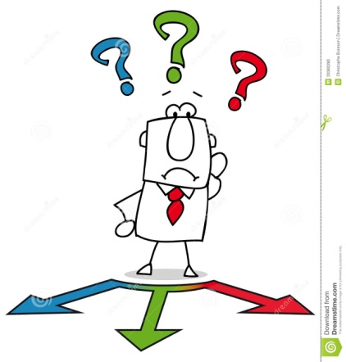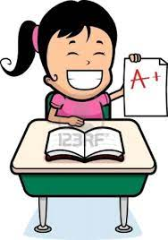
……………… a decision …………. your best …………….. an effort ……………. an impression
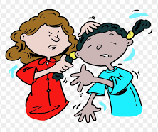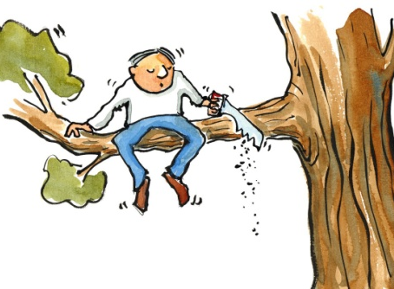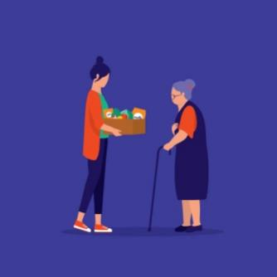
……………… harm ………………… a mistake ……………… a favour ……………. money
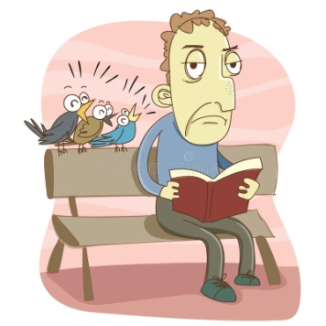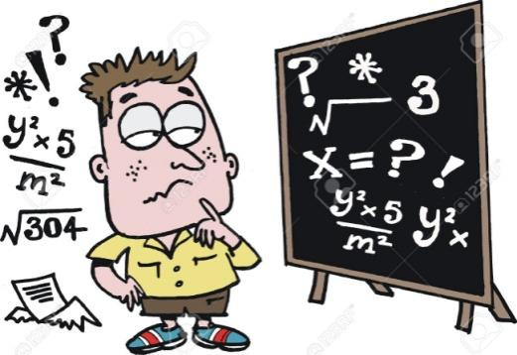
………………. noise ………………. progress …………. the housework …………….. sense

- I ‘ve …………………………………………………… in the maths test, so I don’t expect a high grade.
- Always ………………………………………………….. at a competition!
- His handwriting was so bad that I couldn’t …………………………………………….. of what he wanted to say!
- Dan must …………………………………………………. if he will leave the job or not.
- The road workers ………………………………………………… so I couldn’t concentrate on my homework.
- Smoking and drinking alcohol …………………………………………….. .
- Will you …………………………………………? Will you buy me some milk on your way home?
- The young actress ……………………………………… in the Oscar Awards ceremony.
- Mum doesn’t have much time to ……………………………………………….., so we all lend a hand.
- Students with low grades must ……………………………………….. to do better at the second semester.
- My grandfather moved to the USA and ……………………………………….. .
- After studying more, Harry ……………………………………………… with his schoolwork.

18

Let’s Practise: Articles - Prepositions
A) Put in a/an, the or –
1. There was ………….. waiter standing at ………… entrance of ………… restaurant. ………….. waiter was kind.
2. “Is that your wife?” “No, my wife’s ………. woman in ………. red dress.”
3. I work with ………. man and two women. ………. man is quite nice, but ………. women are not very friendly.
4. Can you show me ………. that book, please? ………… red one with ……….. picture on the cover.
5. ……….. water turns into ……….. ice at 0 degree C.
6. I like ………… steak, but I don’t like ……….. eggs.
7. She lives in ………… nice flat on ………. fifth floor of ……….. old house.
8. I bought ……. hat and ……… bracelet. …… hat is in my bag but I don’t know where ………… bracelet is.
9. We don’t go to ….….. cinema very much these days. In fact, in ………. town where we live there isn’t ……… cinema. 10. Did ………. police find ………. person who stole your bicycle?
11. We went out for ………… meal last night. ………… restaurant we went to was excellent.
12. After the accident, Harry went to ………… hospital. The doctor advised him to stay in ………… bed.
13. The thief was sent to ………… prison. His wife often visits him in ……….. prison.
14. ………… youngest boy has just started going to ……….. school; ………. eldest boy is at ………… university.
15 . Dad went to ………… school to talk to ………… headmistress about my progress.
16. My mother goes to …………church in …………. morning, and in ………… afternoon goes to visit ………… friends.
17. There was ………. knock on ………. door. I opened it and saw ………… man in ………. overcoat and ……… hat.
18. I have ……….. little money left; let’s have dinner in ……….. restaurant.
19 ………. important products which we get from ………… India are ……….. tea, ……… cotton, and ………… rice.
20. I go to work by ………… underground ………… every day while my sister takes …………. bus.
21. ………… sun is shining but part of ………… sky is still covered with ………… clouds.
22. Sometimes we must take ………… medicine.…………. . medicine which ………….. doctor prescribed helped me a lot.
23. He likes to study ………….. French. She wants to go to France.
24. He works in ………… building on ………… corner of ………. Wellington street.
25. ………… Tokyo is one of the ………… largest cities in ……….. world.
26. …………. Mississippi is …………. largest river in …………. USA.
27. ………… Lake Ontario is in ………….. Canada.
28. …………. Mount Everest is ……………….. highest mountain in ………….. world.
29. ……….. Alps is ……… highest mountain range in Europe.
30. Corfu is ……… beautiful island. It belongs to …………. Seven Islands.
31. ………….. Asia is …………… largest continent in ………….. world.
B) Complete with the correct preposition

- Please try and listen …………………. my instructions.
- Don’t laugh ………………….. me! I’m not a funny clown!
- Lou apologized …………………… her mistake.
- Sue paid …………………….. my ticket.
- Do you believe ………………….. ghosts?
- Does this bag belong ………………… you?
- Albert was accused ……………….. stealing.
- Wendy succeeded ……………………… passing the exam.
- Are you interested ……………………… computers?
- I’m not very keen ……………………. swimming.
- I feel sorry …………………… Sam because he hasn’t got any friends.
- Don’t be jealous ……………………. your friends. It’s very bad!
- Helen is married ………………….. Jack.
- Harry is really good ………………… maths.
- You can really rely …………………… me.
19
Let’s Learn: A sound mind in a sound body

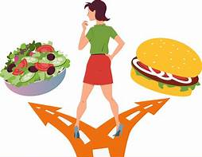
Breakfast: Never skip / slip breakfast because it gives us valuable nutrients which our body needs to develop properly. Breakfast should mainly consist from / of cereals and diary / dairy products, orange juice, eggs, marmalade, bread and butter. They all provide / produce our body with vitamins, fibres, minerals and other basic substances which give us energy and protect us from viruses and other diseases. They build up /over our immune system.
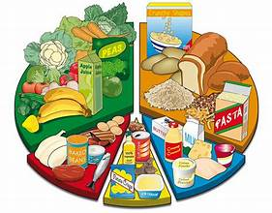
Diet: Always watch your diet because we are what we eat. Try to adapt / adopt a balanced diet avoiding junk food, salty, sugary and fatty snacks. These snacks are very fattening, and increase the risk of suffering from obesity or heart diseases later in life. So, eat low-fat products, vegetables and fruit which have nutritional cost / value so as not to gain / take weight. Adopt healthy eating customs / habits. Finally remember that home cooking / ready- made meals can help you remain fit and healthy. Have / Bear in mind that many foods and drinks, such as tinned food, processed food and fizzy drinks have lots of harmful chemicals, preservatives, and additives / preserves. So, if you want to please / satisfy your hunger between the main meals of the day, eat some fruit or drink some natural juice. Always go for the best food choices.
Get Exercise: Get out of bed and exercise if you want to be in good shape / formation and be healthy. Today, advertisements in magazines and work-out videos online both stress the importance of regular exercise and nutritious diets. Exercise, in particular, clears our minds and helps us fight sedentary / sitting modern lifestyles.
- Why is breakfast an important meal? What should we do?
- What does an ideal breakfast consist of?
- Why are sugary, salty or fatty snacks life-threatening?
- What is the problem with processed food and fizzy drinks?
- What kind of snack can you grab if you feel hungry?
- Why is exercise as important as a balanced diet?
- What is a “sedentary lifestyle?

- Use the following verbs in the correct form to complete the sentences.
avoid go on keep take up stay give up cut down on
- Playing basketball once a week ……………………………………… me fit.
- Lots of fresh fruit and vegetables will help you to …………………………….. healthy.
- My doctor keeps telling me I should ……………………………… smoking.
- You eat too much sugar, you should ………………………………. it.
- If you can, try to ………………………………. stressful situations.
- I’ve put on some kilos! I must ……………………………….. a diet.
- You must …………………………… eating big meals at night.
- I think, I should ……………………………… a sport or hobby. 20

Let’s Read: Are Teenagers Becoming Couch Potatoes?
Today, many health experts are worried because a lot of teenagers lead a sedentary life. Instead of playing sports or walking outdoors, many young people spend most of their time sitting down and staying inactive.
There are a few clear reasons for this problem. First, teens spend too much screen time watching videos, playing computer games, and using social media. They spend a disproportionate amount of their day in front of screens instead of moving around. Second, schoolwork keeps them sitting for long hours in class and at home. Finally, some cities do not have enough facilities such as safe parks or sports fields, which causes a lot of inactivity.
This habit can make teenagers feel sluggish and physically weak. It can also hurt their mood and mental health. Fortunately, we can fix this. Schools should make physical education more fun and encourage students to move during breaks. Parents can set sensible rules for using phones and organize fun activities outdoors. If teens make a sustainable plan to move every day, they will feel much more energetic!
Read the sentences below. Write True (T) or False (F) based on the text.
- [ ] Homework and schoolwork contribute to the time teenagers spend sitting down.
- [ ] All cities have plenty of facilities for teenagers to exercise.
- [ ] Being inactive can affect a teenager's mood and mental health.
- [ ] The text says schools should ban all smartphones completely.
- [ ] Parents can help by planning active outings with their children.

Complete the summary using the eight bold words from the text.
Many teenagers live a (1) _________________ life because they spend too much time sitting down. They are often (2) _______________ for hours because of high (3) _______________ on smartphones and computers. Spending a (4) __________________ amount of time on screens leads to physical (5) ___________________, which can make teens feel (6) __________________ and tired. To change this, parents should set (7) __________________ limits on devices, and teens need to build a (8) __________________ daily routine with regular exercise.
Let’s Write: What should I do?
- Your best friend has the problems you see in the pictures. Say and write what the problems are.
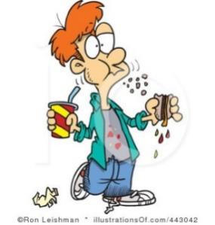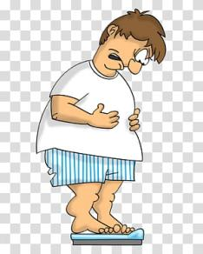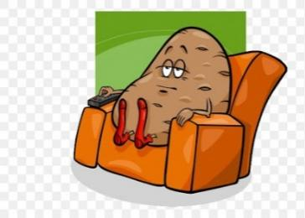
……………………………… ……………………………… ……………………………………… …………………………………………..
- Give him / her advice on how to overcome problems. Use the pictures and the phrases in the box.
Giving Advice
You should / shouldn’t … You could … You must / musn’t … You d’ better …
If I were you, I’d … Why don’t you …? A good idea would be to …..
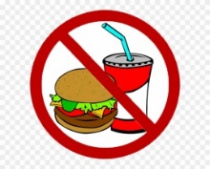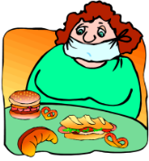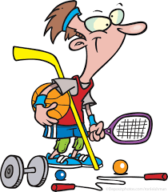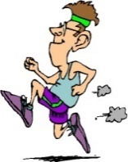
Now, write an e-mail to your friend to give advice.
21
UNIT 4: THE WORLD OF SPORTS
Let’s Learn
TEAM SPORTS
goal build up self-esteem cooperation concentrated rules spirit score

In team sports (1) ………………………… among teammates is the key to success. All players in a pitch or court have to get on well and be united towards a common goal- to beat the rival team and (2) achieve the best………………………….. Of course, they should obey the (3) …………………………….. of the game. Players either attack to score a (4) …………………………….. or play a defensive role to prevent the opposing team from scoring.
These sports encourage team (5) ………………………… and each player has a specific role to play in a team. Therefore, professional players need to do intensive training, be dedicated to what they do and (6) ……………………………….... when playing. No doubt, these sports boost confidence and (7)…………………………………... They also help them get self-discipline and - most important – they (8)…………………………. team spirit and develop social skills.

- What do you need to do in a team sport?
- What are the benefits of team sports?

INDIVIDUAL & ONE-TO-ONE SPORTS
judges intensive discipline against compete participants
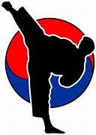
In individual sports, athletes (1) …………………………………… alone, trying to score points or racing (2) …………………………………. the clock. Gymnastics and athletics are individual sports during which (3) …………………………………. perform and (4) ………………………… decide the scores. Like team sports, individual ones need dedication, (5) ……………………………. training, stamina and self-discipline in order to succeed.
On the other hand, in one-to-one sports like boxing, wrestling, martial arts or tennis, athletes compete against one another at a time. Especially Asian martial arts, like karate, tae-kwon-do or judo represent the traditional methods of fighting and defending yourself and their principles are (6) …………………………, confidence and respect to the opponent.

- What are the characteristics of individual sports?
- What are the principles of martial arts?

EXTREME SPORTS
challenge achievement cope overcome daredevils alive
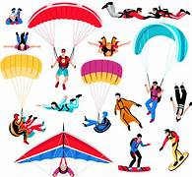
Apart from the common sports, there are extreme sports which (1) …………………………… are crazy about. Extreme sports fans believe that the (2) ………………………………… of facing danger head-on makes them feel alive. Sports like bungee jumping, sky diving or hang gliding get the adrenaline high and make people feel (3) ……………………..! Fans also say that such sports help them (4) ………………………………………… their fears and react quickly in unexpected situations. It gives them a sense of (5) ……………………………… and makes them feel strong and confident to (6) ………………………………with any difficulties they may run into.

- Why do some people choose to do extreme sports? How would you call them?

Use the ideas and the expressions of the three passages to talk and write about the requirements and the benefits of each kind of sports. Use linkers: First, Second, Finally, What is more, Also, Moreover, On the other hand, However 22
Let’s Watch: The Olympics
https://www.youtube.com/watch?v=uSf7-LsmU3Y
Watch the video and tell the class one thing you remember about the Olympics. Then watch again and complete the sentences.
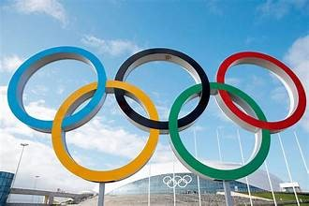
1. The Olympic Games is a celebration of peace and …………………………………….
2. The first Olympics took …………………….. in Greece nearly 3,000 years ago in 776 BC
3. During the games, there was an Olympic Truce, when .......... and battles were not allowed.
4. In the ancient Olympics, only men were allowed to …………………………… .
5. The winners were awarded a wreath or crown of ………………………. branches, which was a great honour.
6. The final games of the ancient Olympics were ………………… in 393 AD, ending a tradition of over a thousand years.
7. The first games organized by the International Olympics Committee took place in Athens, Greece in ……………………
8. The Paralympics began to be held for athletes with ………………………………….
9. While the Ancient Olympics were held at the same place each time, the modern Olympics are held in different ………………………….. around the world.
10. In modern Olympics the winners ……………………………………….. medals.
11. Third place wins ……………………………, second place wins silver and first place gets a gold medal.
12. Another important ………………………………….. of the Olympics is the Olympic rings.
13. Each of the rings represents one of the five inhabited ………………………………….. of the world.
14. After the rings, one of the most important symbols of the Olympics is the Olympic …………………………………….. .
15. Before each Olympics, the torch is lit in a special ……………………………… at ancient Olympia, Greece.
16. The torch then makes a special journey to the city that will ……………………………. The Olympics.
17. When the flame is put out, it means the ………………………………….. end of the games.
18. The goal of the Olympics is to build a better world through international cooperation, ………………………………….. and love for the games.
19. The most important thing in the Olympics is not to win but to take …………………………………. .
Now take notes and talk about five differences between the ancient and the modern Olympics
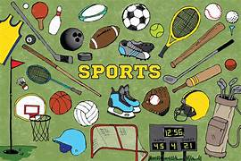
Let’s Learn: SPORTS VOCABULARY
- The person who trains players is called a captain / coach.
- Football is played in a court / pitch.
- Weight lifting requires vivid / intensive training.
- Basketball is played in a course / court.
- People who support a team are called fans / spectators.
- A coach’s job is challenging / uninteresting and rewarding.
- Do you believe our team will win / beat the opponents?
- Figure skating is a sport in which individuals or pairs perform on an ice ring / rink.
- I challenge you to a bowling contest, so let’s meet at the bowling line / alley.
- Wimbledon is a prestigious tennis tournament / contest that is held every summer.
- The majority of the viewers / spectators at the match were supporters of the local team.
- The umpire / referee blew the whistle to end the football game.
- The athlete ran around the track / arena so quickly that she broke her own record.
- A good coach always stands up for / stands out of his players.
- How many teams are contesting / are competing in the championship this year?
- The final score was 3-3, so it was a(n) draw / equal.
- Sportspeople receive huge financial awards / rewards these days.
- Although the team was out of / without practice, they managed to win.
23

Let’s Practise: Conditionals

A) Choose the correct item and underline it:
1. If I move / I’ll move to Boston, I live / I’ll live on Main Street.
2. If you call / you’ll call your mother, she’ll be very happy.
3. If the mechanic fixes our car on time, we drive / we’ll drive to Athens.
4. If it rains / it’ll rain today, we won’t go to the park.
5. If I’m not in a hurry tonight, I text / I’ll text her.
6. If she isn’t / won’t be sick, she’ll go to school.
B) Find correct items and complete the following sentences:
1. If we ….. go …….. to London, …… we’ll ………. visit our cousin.
2. If they ………………. their homework tonight, their teacher ……………………. happy.
3. If the weather ………………… good, George ………………… swimming this weekend.
4. If you don’t eat your dinner tonight, ……………………………………………... hungry.
5. If .they …………………………..tired, they’ll go to sleep early tonight.
6. If you ………………... too many cookies after dinner tonight, ………………get a stomachache.
C) Complete the sentences with your own ideas
1. If the weather is bad tomorrow, ……………………………………………………..…………………….……………………..
2. If I don’t sleep well tonight, ………………………………………………………………………………………….………………
4. If you don’t fix the broken window, ……………………………………………..………………………………………………
5. If I go to London, ………………………………………………………………………... ……………………………………………….
6. If ……………………………………………………………………………………..………..,they’ll go to a restaurant tonight.
7. If …………………………………………………………………………….……………………………., his mother will be happy.
8. If I become rich, …………………………………………………………………………………………………………………………….
9. If I study hard, ………………………………………………………………………………………..………………………………………
12. If it’s sunny at the weekend, ……………………………………………………………...
D) What would you do in each situation?
* call an ambulance * complain to the manager * run away* try to catch it * ring the police* walk to the nearest garage to get some
1. You find a fly in your soup. If I found a fly in my soup, I would complain to the manager.
2. You see a burglar breaking into your house.………………………………………………..…………………………………………………..
3. You see a mouse in your kitchen.………………………………………………………………..…………………………………………………..
4. Your car runs out of petrol.……………………………………………………………………….……………………………………………………..
5. You see an accident.………………………………………………………………………………………………………………………………………..
6. You see a ghost in your room.……………………………………………………………….………………………………………………………….

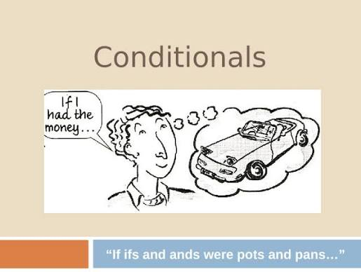
E) Use the correct tense:
1. The teacher will be very angry if you …………………………… (not do) your homework.
2. If he ……………………………….. (tell) me, I could help him.
3. If you don’t water the flowers, they ………………………………………… (die).
4. If you didn’t water the flowers, they …………………………………………(die).
5. I ……………………………………….. (come) if I had time.
6. If you don’t hurry, you ……………………………………….. (miss) the bus.
7. If I …………………………… (be) you, I wouldn’t buy that car.
8. He will play tennis if the weather …………………………………. (be) good.
9. I would be very happy if she …………………………………. (be) my sister.
10. She could win the race if she …………………………………. (try).
11. If he ……………………….. (go) to bed early, he will get up early.
12. I wouldn’t say it if I ……………………….. (be) you.
24

F) Match 1-10 with a-j
1. Everyone on board the plane would have died a) If I had not been to a doctor.
2. If the officials hadn’t stopped the poor man, b) if you had taken him to the fun-fair.
3. If the climbers had found an easy way, c) if the plane had crashed.
4. I would be in a hospital now d) she could have bought some expensive clothes.
5. We would have got wet e) so many people wouldn’t have been killed.
6. If he had had enough time last summer, f) he could have built his small house in two days.
7. I might have come to your help g) if we hadn’t taken our umbrellas.
8. If the driver had not slept, h) they could have reached the top easily.
9. The young boy would have been very happy i) he would have gone on a holiday.
10. If her father had been rich, j) if I had had time last Sunday

G}Fill in the correct form of the verb. Use the type given at the end of the sentence.
1. If he __________________ (eat) everything, he ______________________ (be) ill (3)
2. The police ______________________ (arrest) him if they ____________________(catch) him (1)
3. What ______________________ (happen) if my parachute __________________(not open)? (1)
4. I ______________________ (be) angry if he _____________________(make) more mistakes. (2)
5. If he ______________________ (be) late, we ______________________ (go) without him (3).
6. If I ________________(lend) you 10 pounds, ___________________ (you, give) it back to me? (1)
7. If you _________________ (not like) this T-shirt, I __________________ (bring) you another one. (1)
8. If I ______________________ (know) that, I ______________________________ (visit) you. (3)
9. I ______________________ (not drink) that wine if I ______________________ (be) you. (2)
10. If we __________________ (have) more rain, our crops ____________________ (grow) faster (3)
11. If you ______________________ (paint) the walls white, the room ______________________ (be)
much brighter (1).
12. I ____________________________ (can repair) the roof myself if I ______________________
(have) a ladder. (3)
13. You ______________________ (not have) so many accidents if you ______________________
(drive) more slowly (2).
14. What ______________________ (you, do) if you ______________________(hear) the alarm? (2)
15. If you ______________________ (go) to Paris, where ______________________ (you stay)? (1)
16. I __________________________ (bring) you something to drink if you ______________________
me (tell) (3).
17. If anyone ______________________ (attack) me, my dog ______________________ (jump) at
him (3).
18. If everybody ______________________ (give) me 3 pounds, we ______________________
(have) enough. (1)
19. This __________________________ ( not happen)if you ______________________ (be)more
careful (3)
20. We ______________________ (invite) him if he ______________________ (be) at home(2)
21. I ______________________ (put) some money into the bank if I ______________________
(have)some left (2)
22. I ______________________ (offer) them coffee and cake as soon as they
_________________________ (come) over (1)
23. If you ______________________ (give) me the letter, I __________________________ (post) it for
you (3)
25
Sports and Equipment
- Write the correct word under the picture.
boxing gloves goggles (table tennis ) bat net roller skates goalpost surfboard knee pads weights tennis racket safety helmet hoop
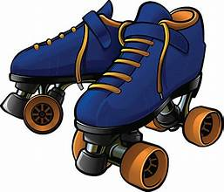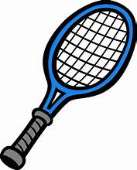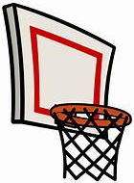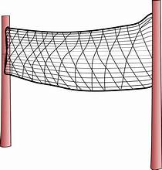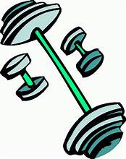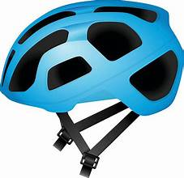
1………………………………. 2……………………… 3………………………. 4…………………………. 5………………………. 6……………………
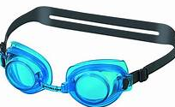 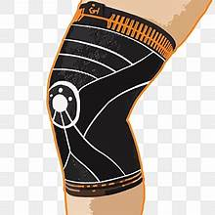  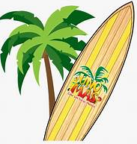 .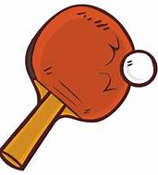 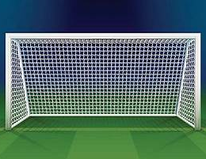
7……………………………… 8………………………… 9…………………….. 10………………….. 11……………………… 12…………………………
- Now make sentences as in the example.
- If you want to go rollerblading, you ‘ ll certainly need rollerblades.
- ……………………………………………………………………………………………………………………………………..
- ……………………………………………………………………………………………………………………………………..
- ……………………………………………………………………………………………………………………………………..
- ……………………………………………………………………………………………………………………………………..
- ……………………………………………………………………………………………………………………………………..
- ……………………………………………………………………………………………………………………………………..
- ……………………………………………………………………………………………………………………………………...
- ………………………………………………………………………………………………………………………………………
- ………………………………………………………………………………………………………………………………………
- ………………………………………………………………………………………………………………………………………
- ………………………………………………………………………………………………………………………………………
- Make sentences as in the example.
  - Bryan forgot his goggles, so he got sore eyes after the pool.
If Bryan hadn’t forgotten his goggles, he wouldn’t have got sore eyes after the pool.
  - Sue forgot her racket, so she didn’t play tennis.
  - The net was torn, so they didn’t play volleyball.
  - The hoop was broken, so the basketball game was cancelled.
  - Sam wasn’t wearing a helmet, so he hit his head when he fell off the bike.
  - Jake didn’t have his knee pads on, so he hurt his knees.
  - Luke’s bat was broken, so he missed the table tennis match.
  - The football field was flooded, so the match was put off.
  - I didn’t find my rollerblades, so I couldn’t go rollerblading.
26

.UNIT 5: CHILDREN IN THE PAST
Let’s Read & Learn

Victorian Child Labor
Victorian Child Labor was normal in the 1800’s. There was no such thing as Child Protection Services like we have today. Among the most common jobs children used to do were:

Coal Miners
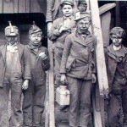
Steam was number one source of energy during Victorian times. Steam powered everything from trains and steamships to factories that used steam to power their machines. In order to make steam you must have water and heat. To provide heat they had to burn lots of coal. The thought of using children for working the coal mines was very attractive to mining companies. Children were much smaller, which made it easier to move in narrow spaces and they demanded less pay.
The working conditions were dreadful. The mines were dark, making it hard to see and at times it would cause permanent sight problems. Due to a lack of proper ventilation, coal dust was very thick in the air. Considering that Victorian Children would work from 12 to 18 hours a day, it is easy to see how breathing problems used to arise. There was terrible noise, and rats in the mines. Explosions were very common, too. Due to lack of safety measures death was a constant threat.

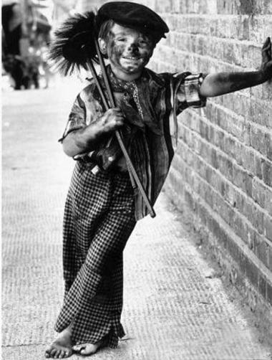
Chimney Sweeps

The life of a chimney sweep in Victorian times was brutal. Some were as young as 3 years old. Their tiny size made them a popular choice for going down the narrow chimneys.
It was the most dangerous job for children in the 1800’s, especially when the child first started the job. Getting down the chimney the first times would cause the child’s arms, elbows, legs and knees to be rubbed and scraped. At times, their knees and elbows looked like there was no skin at all on them. The boss used to wash their wounds with salt water and send them down another chimney without sympathy.
But the dangers of the job were only beginning. Falling or getting stuck in the chimney was a major fear for chimney sweeps because they could both cause death very easily. There were a few reported cases of children getting stuck in chimneys and no one even knowing it, leaving them to choke from smoke inhalation.

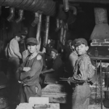
Factory Workers
Factory and mill owners saw children as cheap effective labor. They worked for a mere fraction of what an adult earned. And girls were even cheaper. Because of their size and youthful energy there were jobs that children performed as well or even better than adults. Sometimes there were more children than adults working at a factory.
At the factories children had no rights. The dirtiest jobs were given to children. Many times a child would be told to clean under machines even while they were running. There were few or no safety measures in Victorian times, so injuries and even death were common. Victorian child labor consisted of very long working hours. The normal work week would be Monday to Saturday from 6 a.m. to 8 p.m. Children would be beaten or fined for falling asleep, making a mistake or being late.

Victorian Child Labor was nothing new for Britain or all of Europe because children had been used for labor for centuries. It was expected of them to help support their families. During the 1800’s awareness began to grow toward the ills of child labor in factories and elsewhere. Laws were passed until the use of children under the age of 16 was prohibited for full-time work.
In 1881 Thomas Agnew, a Liverpool businessman visited the New York Society for the Prevention of Cruelty to Children. He was so impressed by what he saw that he went back to England and started the Liverpool Society for the Prevention of Cruelty to Children. This set the ball rolling and the National Society for the Prevention of Cruelty to Children (NSPCC) was created in 1891.
27
- Explain the highlighted words. Then, match eight of them with their synonyms.

- awful, frightening ………………………………….. e. pleasing, alluring ……………………………………….
- deep and dense ……………………………………… f. not new at all ……………………………………………
- harsh, barbaric ……………………………………….. g. forbidden, made illegal …………………………………
- a tiny part ……………………………………………… h. not wide, limited …………………………………………

- Complete the sentences with the correct word. Look back in the text.

- Victorian Child Labor was ………………..………………….. in the 1800’s
- The ………………………….. of using children for working the coal mines was very attractive to mining companies.
- The ………………………………………………………………… were dreadful.
- There was terrible …………………..……………. and ……………….………………… in the mines.
- Due to the lack of …………………….…………………….. in the mines death was a constant threat.
- The life of a chimney sweep in Victorian times was …………………….……………………….
- Getting down the chimney would cause the child’s arms, …………..…………………, legs and …….……………………….. to be rubbed and scraped.
- Falling or getting stuck in the chimney was a ……………………..……………………. for chimney sweeps because they could both cause ……………………………………….
- Sometimes you would find more children than ……………………………… working at a ………………………………………….
- At the factories children had no …………………………………..………….
- Victorian child labor consisted of very long …………………………………..…………………….
- Children would be ……………………………………. or fined for falling asleep, making a ………………………………………… or being late.
- Say and write three things Victorian children used to do as:

Coal miners: ………………………………………………………………………………………………………………………………………………………….
…………………………………………………………………………………………………………………………………………………………………………………………………………………………………………………………………………………………………………………………………………………………………………
Chimneysweeps: …………………………………………………………………………………………………………………………………………………………………………………………………………………………………………………………….............................................................................................................................…………………………………………………………………………………………………………………………………….
Factory workers: ……………………………………………………………………………………………………………………………………………………
…………………………………………………………………………………………………………………………………………………………………………………………………………………………………………………………………………………………………………………………………………………………………………
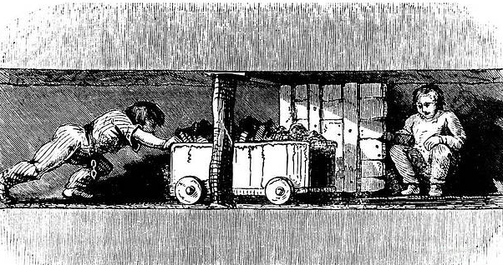
28

Lets’ Practice: too & enough

A) Complete the sentences. Use ENOUGH with one of these words:
big eat fruit loud old practise sugar time tired
1. A: “Is there …. enough sugar … in your coffee?”
B: “Yes, thank you.”
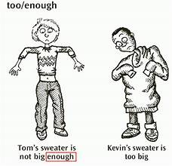
2. Can you hear the radio? Is it …loud enough …… for you?
3. He can leave school if he wants – he’s …………………………… .
4. Did you have ………………………….. to answer all the questions in the exam?
5. This house isn’t ……………………………….. for a large family.
6. Tina is very thin. She doesn’t ……………………………………… .
7. You don’t eat ………………………………… . You should eat more – it’s good for you.
8. It’s late but I don’t want to go to bed now. I’m not …………………………………. .
9. Lisa isn’t a very good tennis player because she doesn’t ………………………………. .

B) Complete the sentences. Use ENOUGH with the words in brackets:
1. We haven’t got ……. enough money to buy ……. a car. (money / buy)
2. This knife isn’t ……………………………………..…………………… tomatoes. (sharp / cut)
3. The water wasn’t …………………………………………………….. a bath. (warm / have)
4. Have we got …………………………………………………. sandwiches? (bread / make)
5. We played well but not ………………………………….……………… the game. (well / win)
6. I don’t have ……………………………………………….……………. newspaper. (time / read)

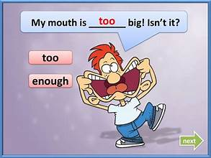
C) Put in TOO or ENOUGH:
1. You’re always at home. You don’t go out ….. enough. ……
2. I can’t wait for them. I haven’t got …………………. time.
3. You’re always tired. I think you work ………………….. hard.
4. A: Did you have ……………………. to eat?
B: Yes, thank you.
5. You don’t eat …………………… vegetables. You should eat more.
6. I don’t like the weather here. It’s …………………… cold.
7. The radio isn’t loud …………………... . Can you turn it up, please?
8. She speaks ………………….. fast for me to understand.
9. Don’t buy that coat. It’s nice but it isn’t long ………………….. .
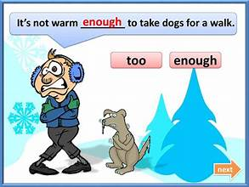
10. He can’t reach the shelf. He isn’t tall ………………………… .

E) Complete the sentences. Use TOO (+adj.) + TO (do something):
1. (I’m not going out / cold) ….. It’s too cold to go out. ………………
2. (I’m not going to bed / early) It’s ……………………………………….
3. (they’re not getting married / young) They’re …………………………………..
4. (nobody goes out at night / dangerous) It’s ……………………………………….
5. (don’t phone Ann now / late It’s ……………………………………….
6. (I didn’t say anything / surprised) I was …………………………………….

29
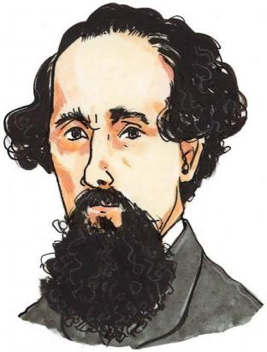
Charles Dickens: The Voice of the Forgotten
Charles Dickens (1812–1870) was one of the most famous English authors of the Victorian times .Born in Portsmouth, England, Dickens experienced the horrors of poverty firsthand. When he was just 12 years old, his father was sent to prison for debts, forcing young Charles to leave school and work long, brutal hours at a blacking (shoe polish) factory. This traumatic childhood experience stayed with him forever and inspired his lifelong passion for defending the rights of poor children.
As an adult, Dickens became a journalist and novelist, using his powerful storytelling to talk about social injustice. His second novel, Oliver Twist ( between 1837 and 1839), was a direct attack on the Poor Law Amendment Act of 1834. This law forced poor families, orphans, and unemployed adults into strict, prison-like institutions called workhouses. In exchange for basic food and shelter young children were forced to work long hours, eat tiny food portions, and live under the fear of harsh punishment.
Oliver Twist was a massive popular success that changed how public opinion viewed child labor and poverty.
Before Dickens wrote the novel, many wealthy Victorians believed that poverty was caused by laziness and that workhouses were a fair solution. Oliver Twist shattered this belief. By putting a human face on child suffering, Dickens shocked the public conscience and forced politicians to confront the cruelty of the workhouse system.
Match the underlined words with their meanings
- ….………………………………….. A place that provides protection from bad weather or danger.
- ….………………………………….. Very large, heavy, or powerful.
- ….……………………………………. The state of being extremely poor.
- ….…………………………………… To face a difficult situation or person directly.
- ….……………………………………… Money that you owe to someone else.
- ….……………………………………….. Filled with a urge or ability to do something creative or good.
- ….………………………………………..Treating people equally or right according to the rules.

The World of Oliver Twist!
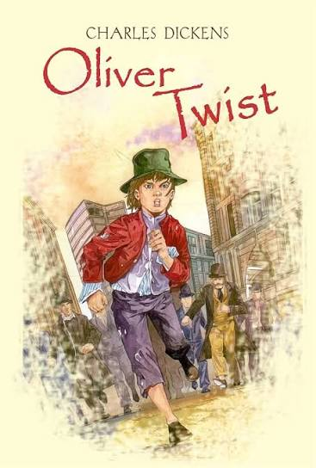
Imagine living in a city where the streets are dark, cold, and crowded, and where having a warm meal every day feels like a dream. This is London in the 1800s, the setting of the famous novel Oliver Twist by Charles Dickens.
The story follows a young orphan named Oliver Twist. Oliver grows up in a terrible place called a workhouse, where poor children must work hard and receive very little food. One day, Oliver does something extremely brave (and dangerous!): he asks the strict manager for a second bowl of soup. This famous moment changes his life forever, as he is immediately thrown out of the workhouse to find his own way in the world.
Oliver runs away to London, hoping for a fresh start. Instead, he meets a boy called the Artful Dodger, who introduces him to Fagin—an old man who leads a gang of young thieves. Oliver accidentally becomes part of this criminal world, but all he really wants is a peaceful life and a loving family.
Oliver Twist is an exciting adventure full of mystery, dangerous villains, and unexpected friends. As you read, you will explore themes of friendship, good versus evil, and hope in difficult times. Will Oliver escape the thieves and find a safe home? Turn the page to find out! 30

Oliver Twist: The Film
- Match the character on the left with the correct description on the right.
- Oliver Twist — A. A cruel, violent thief who owns a fierce dog named Bull's-eye.
- Fagin — B. A kind, wealthy gentleman who rescues Oliver from a life of crime.
- The Artful Dodger — C. A corrupt workhouse official who mistreats orphans and loves food.
- Nancy — D. A lonely, innocent orphan boy who faces many hardships in London.
- Bill Sikes — E. A clever, young pickpocket who introduces Oliver to Fagin's gang.
- Mr. Brownlow — F. A compassionate young woman who risks her safety to help Oliver.
- Mr. Bumble — G. An old, greedy man who trains homeless children to steal for him.
- Toby Crackit — H. A kind housekeeper who nurses Oliver back to health at Mr. Brownlow's house.
- Mrs. Bedwin — I. A sinister man who hates Oliver and plots with Fagin to ruin his life.
- Monks — J. A flashy, talkative burglar who assists Bill Sikes in a broken-in robbery.
- Decide if the following statements are True or False.
Part 1: Early Life and Workhouse
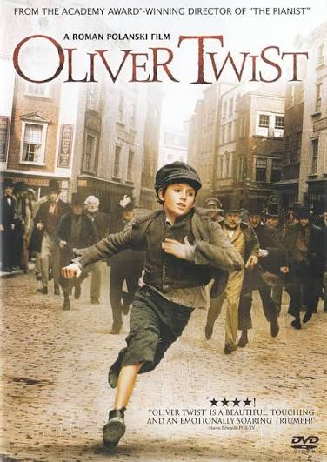
- At the beginning of the movie, Oliver is escorted to the workhouse by Mr. Bumble. ( T / F )
- The boys in the workhouse draw straws to decide who will ask the master for more food. ( T / F )
- When Oliver asks for more food, the board members applaud his bravery and give him an extra serving. ( T / F )
- Mr. Sowerberry, the undertaker, hires Oliver to work as a "mute" mourner at funerals. ( T / F )
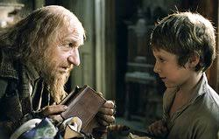
- Oliver decides to run away to London after getting into a fight with Noah Claypole. ( T / F )
- Oliver takes a train to reach London in less than two hours. ( T / F )
Part 2: Arrival in London and Fagin's Gang
7. The Artful Dodger meets Oliver on his way to London and offers him food and shelter. ( T / F )
8. Fagin's gang consists mostly of adult criminals who force Oliver to work in a factory. ( T / F )
9. Fagin teaches the young boys how to pick pockets by playing a game with a handkerchief in his pocket. ( T / F ) 31
10. Nancy is a young woman who is sympathetic towards Oliver and treats him with kindness. ( T / F )
11. Bill Sikes is portrayed as a gentle, soft-spoken friend of Mr. Brownlow. ( T / F )
12. Bill Sikes owns a dog named Bullseye. ( T / F )
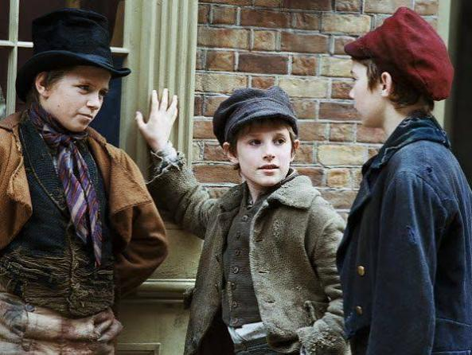
Part 3: The Arrest and Mr. Brownlow
13. Oliver is arrested after successfully stealing a gold watch from Mr. Brownlow himself. ( T / F )
14. The Artful Dodger and Charley Bates escape while Oliver is caught by the crowd. ( T / F )
15. Mr. Brownlow realizes Oliver is innocent and decides to take him into his home to care for him. ( T / F )
16. While staying at Mr. Brownlow's house, Oliver is given clean clothes and treated with great kindness. ( T / F )
17. Mr. Brownlow sends Oliver out to return some books and money to the bookseller to test his honesty. ( T / F )
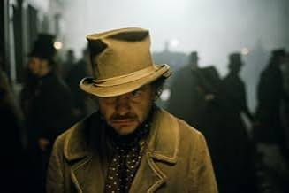
Part 4: The Kidnapping and Robbery
18. Fagin and Bill Sikes want Oliver back because they are afraid he will tell the police about their gang. ( T / F )
19. Nancy and Bill Sikes kidnap Oliver off the street while he is returning books for Mr. Brownlow. ( T / F )
20. Sikes takes Oliver with him to break into Mr. Brownlow's country house. ( T / F )
21. During the attempted burglary, Oliver is shot and wounded. ( T / F )
22. Fagin and Sikes agree that Oliver knows too much and should be hidden away safely in the countryside. ( T / F )
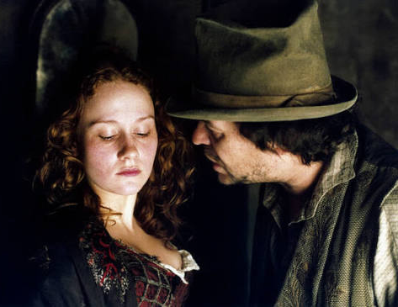
Part 5: Nancy’s Betrayal and Climax
23. Nancy meets Mr. Brownlow on London Bridge to inform him about Fagin and Sikes's plans to hurt Oliver. ( T / F )
24. In Polanski’s film, Fagin sends the Artful Dodger to follow Nancy and spy on her. ( T / F )
25. After discovering that Nancy met with Mr. Brownlow, Bill Sikes attacks and kills her. ( T / F )
26. Sikes tries to drown his dog, Bullseye, because he fears the dog will lead the police to him. ( T / F )
27. Sikes escapes on the rooftops, but accidentally hangs himself when he loses his balance. ( T / F )
32
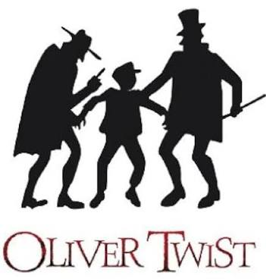
Part 6: Resolution and Ending
28. In Polanski's film, Oliver's evil half-brother Monks appears at the end to claim his inheritance. ( T / F )
29. At the end of the movie, Oliver visits Fagin in Newgate Prison before Fagin's execution. ( T / F )
30. Oliver feels no pity for Fagin in prison and refuses to see him. ( T / F )

"Who Said It?" / Quote Matching Game
Match each famous line (1–10) with the character who spoke it.
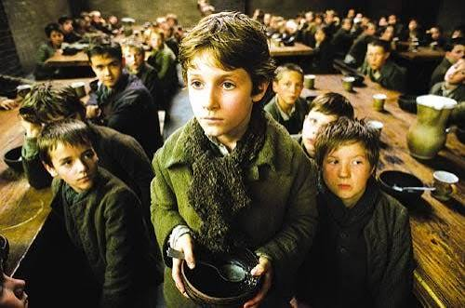
Characters to Choose From:
- Oliver Twist
- Fagin
- The Artful Dodger
- Bill Sikes
- Nancy
- Mr. Brownlow
- Mr. Bumble
- "Please, sir, I want some more."
- "What! Oliver Twist has asked for more! That boy will be hung!"
- "I've got a home for you in London, mate. An old gentleman lives there, who'll give you lodgings for nothing."
- "Make yourself at home, my dear, make yourself at home!"
- "You've been stolen from a good home, Oliver... and I'd give my life to put you back there."
- "Hold your tongue, or I'll silence you for good!"
- "There is something in that boy's face that touches my heart, rather than makes me angry."
- "Clever boys, my dears! Very clever boys! They've brought back so many fine handkerchiefs!"
- "I am a thief myself, but I am not going to let you harm that poor child!"
- "Look at his clothes! They're far too clean for a boy like him—he belongs to us!"
Write captions for the following pictures
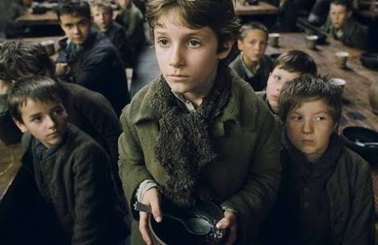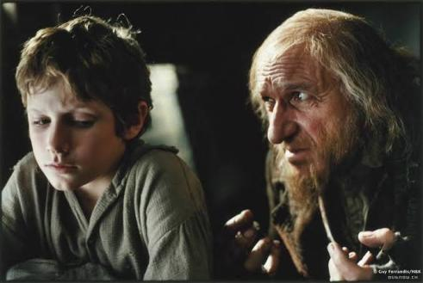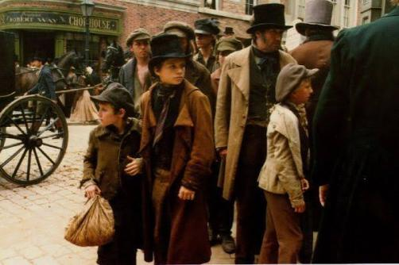
….…………………………………………………….. ……………………………………………………….. ………………………………………………………
….…………………………………………………….. ……………………………………………………….. ………………………………………………………33
Grammar Overview
REWRITE or COMBINE the following:
1. It rained this morning. The children played in the garden. (while)
……………………………………………………………………………………………………………………………………………………………………….………
2. What did you do? The doorbell rang. (when)
………………………………………………………………………………………………………………………………………………………………………………
3. I walked along Main Street. I realized a man behind me. (when)
………………………………………………………………………………………………………………………………………………..……………………………
4. I started to play football when I was five. (since)
………………………………………………………………………………………………………………………………………………………………………………
5. The windows are dirty. I last cleaned them last month. (since)
………………………………………………………………………………………………………………………………………………….…………………………
6. He last sent June a message a week ago. (for)
…………………………………………………………………………………………………………………….…………………………………………………………
7. Maybe the train leaves at six. I can catch it. (If)
………………………………………………………………………………………………………………………………………………………………………………
8. We slept last night. The robber stole all the jewellery. (as)
………………………………………………………………………………………………………………………………..………………………………………………
9. Tom prefers learning French to learning Japanese. (would rather)
……………………………………………………………………………………………………………………………………………….…………………………………
10. Angela looks after many children. It keeps her busy. (gerund)
……………………………………………………………………………………………………………………………………………………………….…………………
11. He went to London. He wanted to work there. (to)
…………………………………………………………………………………………………………………………………………………………………………………
12. They had a picnic. The forest caught fire. (as)
…………………………………………………………………………………………………………………………………..……………………………………………
13. No sound could be heard. The walls were very thick. (because)
………………………………………………………………………………………………………………………………………………..…………………………………
14. My bed is terribly hard. I can’t sleep well. (so ……… that)
……………………………………………………………………………………………………………………………………………………….…………………………
15. The shopkeeper doesn’t let the children put their fingers on the glass while they are looking at the sweets. (be allowed to)
……………………………………………………………………………………………………………………………………………………………………………………
16. My mother would rather cook than iron. (prefer)
……………………………………………………………………………………………………………………………………………….……………………………………
17. We bought this house in 1990. (since)
……………………………………………………………………………………………………………………………………………………………………………………
18. He may come late. He will call us. (If)
……………………………………………………………………………………………………………………………………………………………………………………
19. Paris isn’t as crowded as New York. (comparison)
……………………………………………………………………………………………………………………………………..………………………………………………
20. My father would rather read newspaper than watch TV. (prefer)
……………………………………………………………………………………………………………………………………………………………………………………..
21. I don’t have enough money. I can’t buy a new bike. (if)
……………………………………………………………………………………………………………………………………………………………………………………..
22. Dan went on a dark street. They mugged him. (if)
…………………………………………………………………………………………………………………………………………………………………… 34

